Project Data Summary

Group Project on Knocking

Contributors:

Christian Price (experiment), Jason Biesinger (R and analysis), Joe Lyon (proposal), Jonathan Wilson (proposal), Jesse Van Horn (final report),

Rex Henretta (R and analysis)

(All participate in each section. Assignments are what we are in charge of and then we lead the others in knowing what to do.)

**Perform the Experiment:**

The experiment was performed on Friday, November 20, and it took two and a half hours. During the experiment Christian ran the engine and showed everyone how to use it. Jason and Rex mixed the right concentration of fuel during for each run while performing the experiment. Jon and Jesse adjusted the air/fuel ratio, and Joe took down the measurements for every run.

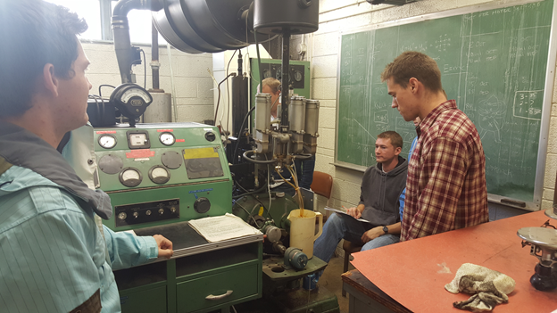

**Experiment Results:**

|  |  |  |  |  |
| --- | --- | --- | --- | --- |
| Run # | Air/fuel ratio | Octane level  (Fuel Resv.) | Replicate | Amount of Knocking |
| 1 | Lean | Booster #1 | 1 | 30 |
| 2 | Rich | Booster #2 | 1 | 58 |
| 3 | Stoichiometric | Regular | 1 | 82 |
| 4 | Lean | Regular | 1 | 75 |
| 5 | Stoichiometric | Booster #1 | 1 | 70 |
| 6 | Lean | Booster #1 | 2 | 30 |
| 7 | Lean | Booster #2 | 1 | 55 |
| 8 | Stoichiometric | Booster #2 | 1 | 75 |
| 9 | Rich | Booster #1 | 1 | 46 |
| 10 | Lean | Regular | 2 | 72 |
| 11 | Rich | Regular | 1 | 61 |
| 12 | Rich | Regular | 2 | 64 |
| 13 | Stoichiometric | Booster #2 | 2 | 76 |
| 14 | Lean | Booster #2 | 2 | 58 |
| 15 | Rich | Booster #1 | 2 | 43 |
| 16 | Stoichiometric | Regular | 2 | 85 |
| 17 | Stoichiometric | Booster #1 | 2 | 70 |
| 18 | Rich | Booster #2 | 2 | 57 |

The reproducible code was submitted via Learning Suite.

**Summary Statistics:**

Table of Means

|  |  |  |  |  |
| --- | --- | --- | --- | --- |
|  | **Regular** | **Booster #1** | **Booster #2** |  |
| **Lean** | 73.5 | 30 | 56.5 | 53.3 |
| **Rich** | 62.5 | 44.5 | 57.5 | 54.8 |
| **Stoichiometric** | 83.5 | 70 | 75.5 | 76.3 |
|  | 73.2 | 48.2 | 63.2 |  |

Table of Standard Deviations

|  |  |  |  |
| --- | --- | --- | --- |
|  | **Regular** | **Booster #1** | **Booster #2** |
| **Lean** | 2.121 | 0.000 | 2.121 |
| **Rich** | 2.121 | 2.121 | 0.707 |
| **Stoichiometric** | 2.121 | 0.000 | 0.707 |